A FIELD PROJECT REPORT

on

**“RAINFALL PREDICTION”**

**Submitted**

221FA04271

Jyothi

221FA04387

Purna sai

221FA04369

Bhanu Teja

221FA04660

Prabhavathi

**Under the guidance of**

***Dr. S. Deva Kumar***

*Designation*



**DEPARTMENT OF COMPUTER SCIENCE & ENGINEERING**

**VIGNAN'S FOUNDATION FOR SCIENCE, TECHNOLOGY AND RESEARCH Deemed to be UNIVERSITY**

**Vadlamudi, Guntur.**

**ANDHRA PRADESH, INDIA, PIN-522213.**

**CERTIFICATE**

This is to certify that the Field Project entitled **“Rainfall prediction”** that is being submitted by 221FA04271(Jyothi), 221FA04369(Bhanu teja), 221FA04387 (purna sai),221FA04660(Prabhavathi)for partial fulfilment of Field Project is a bonafide work carried out under the supervision Ms. Dr. N. Sameera., Assistant Professor, Department of CSE.

|  |  |  |
| --- | --- | --- |
| Guide name& Signature |  | Dr.K.V. Krishna Kishore |
| Assistant/Associate/Professor, CSE | HOD,CSE | Dean, SoCI |



**DECLARATION**

We hereby declare that the Field Project entitled **“Rainfall Prediction”** is being submitted by

221FA04271(Jyothi),221FA04369(Bhanuteja),221FA04387(purnasai)and 221FA04660(Prabhavathi)in partial fulfilment of Field Project course work. This is our original work, and this project has not formed the basis for the award of any degree. We have worked under the supervision of supervision Ms. Dr. N. Sameera., Assistant Professor, Department of CSE.

By

221FA04271(Jyothi),

221FA04369(Bhanuteja),

221FA04387(purnasai),

221FA04660(Prabhavathi)

Date: 15/10/2024

## ABSTRACT

Rainfall is important for food production plan, water resource management and all activity plans in the nature. The occurrence of prolonged dry period or heavy rain at the critical stages of the crop growth and development may lead to significant reduce crop yield. India is an agricultural country and its economy is largely based upon crop productivity. Thus rainfall prediction becomes a significant factor in agricultural countries like India. Rainfall forecasting has been one of the most scientifically and technologically challenging problems around the world in the last century. Rainfall prediction plays a pivotal role in agricultural planning, water resource management, disaster preparedness, and environmental conservation. Accurate forecasting of rainfall can help mitigate the adverse effects of floods and droughts, ensuring better management of food production, irrigation, and water supply. In agricultural nations like India, where a large part of the economy depends on crop yield, predicting rainfall patterns is critical for maximizing productivity and minimizing risks. However, rainfall forecasting is a complex and challenging task due to the dynamic nature of atmospheric conditions. Advances in meteorological models, machine learning, and data analytics have introduced new methods for improving the precision of rainfall predictions, helping farmers, policymakers, and environmental managers make informed decisions.

**TABLE OF CONTENTS**

1. Introduction  
   1.1 Background and Importance of Rainfall Prediction  
   1.2 Overview of Machine Learning in Weather Forecasting  
   1.3 Research Objectives and Scope  
   1.4 Challenges in Rainfall Prediction  
   1.5 Applications of ML in Rainfall Forecasting
2. **Literature Survey**  
   2.1 Previous Studies on Rainfall Prediction  
   2.2 Machine Learning Techniques in Weather Forecasting  
   2.3 Challenges and Gaps in the Existing Systems
3. **Proposed System**  
   3.1 Input Dataset  
   3.1.1 Detailed Features of Dataset  
   3.1.2 Data Sources and Collection Methods  
   3.2 Data Preprocessing  
   3.2.1 Handling Missing Data  
   3.2.2 Feature Scaling and Transformation  
   3.2.3 Data Splitting (Training, Validation, and Testing)  
   3.3 Model Building  
   3.3.1 Machine Learning Models Used (e.g., Linear Regression, Decision Trees, Neural Networks)  
   3.3.2 Model Selection Criteria  
   3.4 Methodology of the System  
   3.4.1 Overview of the Predictive Model Architecture  
   3.4.2 Workflow of Rainfall Prediction  
   3.5 Evaluation Metrics  
   3.5.1 Accuracy, Precision, and Recall  
   3.5.2 RMSE and MAE (Mean Absolute Error)  
   3.5.3 Cross-Validation Techniques  
   3.6 Constraints and Limitations
4. **Implementation**  
   4.1 Environment Setup (Software, Libraries, Hardware)  
   4.2 Sample Code for Data Preprocessing and Model Training  
   4.2.1 Code for Preprocessing  
   4.2.2 Code for Model Training and Testing  
   4.3 System Design and Architecture
5. **Experimentation and Result Analysis**  
   5.1 Experimental Setup and Conditions  
   5.2 Performance Comparison of Different Models  
   5.3 Analysis of Results  
   5.4 Impact of Data Preprocessing on Model Performance  
   5.5 Visual Representation of Results (Graphs, Charts, etc.)
6. **Conclusion and Future Work**  
   6.1 Summary of Findings  
   6.2 Limitations of the Study  
   6.3 Future Enhancements in Rainfall Prediction
7. **7. References**

**LIST OF FIGURES**

|  |  |
| --- | --- |
| Figure 1. Architecture of the proposed system | 18 |
| Figure 2. Logistic Regression-Confusion Matrix | 22 |
| Figure 3. Naïve Bayes-Confusion Matrix | 23 |
| Figure 4. Support Vector Machine (SVM) -Confusion Matrix | 24 |
| Figure 5. Random Forest -Confusion Matrix | 25 |
| Figure 6. XG Boost -Confusion Matrix | 26 |
| Figure 7. KNN -Confusion Matrix | 27 |
| Figure 8. Decision Tree -Confusion Matrix | 28 |

# CHAPTER-1 INTRODUCTION

* 1. **Background and Significance of Rainfall Prediction**

### Introduction

Accurate rainfall prediction is critical for agricultural planning, water resource management, and mitigating the impacts of natural disasters such as floods and droughts. By leveraging machine learning techniques, we can improve the precision of rainfall forecasts and enable better decision-making in weather-dependent sectors. This project focuses on developing a machine learning-based rainfall prediction system using historical weather data.

The dataset consists of 366 records, capturing various weather attributes, such as pressure, temperature, humidity, cloud cover, and rainfall occurrence. These features provide a comprehensive view of daily weather conditions, which can be utilized to predict future rainfall patterns.

**Significance of Rainfall Prediction**

Rainfall prediction holds significant importance across various sectors, playing a critical role in ensuring the sustainability of agriculture, water management, and disaster preparedness. Below are the key areas where accurate rainfall prediction proves to be indispensable:

**1. Agricultural Planning and Food Security**

Rainfall is one of the most important natural resources for agriculture, especially in regions dependent on rain-fed crops. Farmers rely heavily on accurate rainfall forecasts to plan sowing, irrigation, fertilization, and harvesting schedules. By predicting rainfall patterns:

* Crop Yield Optimization: Farmers can make informed decisions about which crops to plant and when to plant them to maximize yield.
* Irrigation Management: Rainfall prediction helps in scheduling irrigation efficiently, ensuring crops receive the required amount of water and minimizing wastage.
* Reduction of Crop Losses: Timely forecasts allow farmers to prepare for floods or droughts, reducing potential damage to crops and safeguarding food production.

**2. Water Resource Management**

Effective management of water resources, such as reservoirs, rivers, and lakes, is closely tied to accurate rainfall predictions. By predicting rainfall:

* Efficient Water Allocation: Governments and agencies can allocate water resources for drinking, agriculture, and industry based on anticipated rainfall levels.
* Reservoir Management: In areas where reservoirs serve as a key source of water, accurate rainfall forecasts help in managing storage levels, preventing overflows or shortages.
* Drought Mitigation: During periods of predicted low rainfall, authorities can take preventive measures, such as rationing water or enhancing groundwater recharge efforts.

**3. Disaster Preparedness and Risk Mitigation**

Severe weather events such as floods, cyclones, and landslides are often preceded by heavy rainfall. Accurate prediction of such events helps authorities and individuals prepare in advance, reducing the impact on lives and property. Rainfall prediction helps in:

* Flood Warning Systems: Early rainfall warnings can trigger flood alerts, allowing for evacuation, preparation of flood defenses, and mobilization of emergency response teams.
* Landslide Prevention: In areas prone to landslides, especially in mountainous regions, rainfall forecasts enable preventive measures, such as slope stabilization and early evacuations.
* Cyclone and Storm Preparedness: Heavy rainfall is often associated with storms and cyclones, and accurate forecasts help in timely disaster management planning.

**4. Urban Planning and Infrastructure Development**

In urban areas, rainfall prediction is essential for flood prevention and the design of infrastructure. Cities, especially those prone to monsoon rains, need to plan drainage systems, roads, and building foundations based on expected rainfall:

* Flood Control in Cities: Rainfall prediction informs the design and implementation of drainage systems that can handle expected rainfall volumes, reducing the risk of urban flooding.
* Infrastructure Durability: Accurate rainfall data can be used to design roads, buildings, and bridges that withstand different weather conditions, enhancing infrastructure longevity.

**5. Energy Production**

Rainfall prediction plays a crucial role in energy sectors that rely on water, particularly hydropower. Energy production from dams and reservoirs is directly related to water levels, which depend on rainfall:

* Hydropower Management: Predicting rainfall allows for better scheduling of electricity generation, optimizing water flow in dams and reservoirs to maintain sustainable energy output.
* Renewable Energy Planning: Rainfall data also supports solar and wind energy forecasts, as rainfall affects solar radiation levels and wind patterns, both of which influence the performance of renewable energy systems.

**6. Environmental Conservation**

Rainfall forecasting helps in maintaining the balance of ecosystems that rely on seasonal rainfall patterns:

* Biodiversity Preservation: Many ecosystems depend on the regularity of rainfall to sustain plant and animal life. Predicting deviations in rainfall can inform conservation efforts and help mitigate the effects of climate change.
* Forestation Programs: Rainfall prediction aids reforestation and afforestation efforts by helping authorities decide when to plant trees for optimal growth.

**7. Economic Stability**

In economies heavily reliant on agriculture, like India, rainfall prediction is vital for economic stability. Accurate forecasts help stabilize agricultural output, reduce uncertainty, and protect livelihoods:

* Market Stability: When farmers have accurate rainfall predictions, they can plan better, leading to more stable crop yields, which positively impacts food supply and market prices.
* Insurance and Risk Management: Rainfall prediction is a key factor in agricultural insurance models, where farmers and insurers rely on weather data to assess risks and settle claims based on anticipated or actual rainfall events.

**Applications of Machine Learning in Weather Forecasting:**

1. **Rainfall Prediction:** Machine learning models analyze historical weather data, such as temperature, humidity, and atmospheric pressure, to predict future rainfall. By learning the correlations between these variables, ML models can forecast the amount and likelihood of rain in a given region with high accuracy.
2. **Temperature Forecasting:** Predicting temperature is one of the fundamental aspects of weather forecasting. Machine learning algorithms can predict daily or hourly temperature fluctuations by analyzing historical patterns and identifying trends in temperature data.
3. **Storm and Cyclone Prediction:** ML models are increasingly being used to predict severe weather events like storms, cyclones, and hurricanes. By analyzing satellite imagery and real-time sensor data, ML algorithms can detect early warning signs of storm formation and forecast the potential intensity, track, and impact of these events.
4. **Wind Speed and Direction Prediction:** Machine learning models are applied to predict wind speeds and directions, which are crucial for sectors like renewable energy (wind power), aviation, and shipping. ML techniques can incorporate data from anemometers, radar systems, and satellites to make accurate wind-related predictions.
5. **Fog and Air Quality Forecasting:** Fog and poor air quality can have significant impacts on transportation and public health. ML models are used to predict the formation of fog or the concentration of pollutants in the atmosphere, helping decision-makers implement necessary precautions and response strategies.

Research Objectives and Scope for Rainfall Prediction Using Machine Learning

The primary objective of this research is to develop a robust and accurate rainfall prediction model using machine learning techniques. Rainfall forecasting plays a critical role in agriculture, water resource management, disaster preparedness, and urban planning, especially in countries like India where the economy is closely tied to agricultural productivity. By leveraging machine learning algorithms, this research aims to enhance the ability to predict rainfall patterns, both in the short term and long term, thereby improving decision-making processes across these sectors.

**Research Objectives:**

1. **Data Collection and Preprocessing:**
   * Utilize historical weather data including rainfall, temperature, humidity, wind speed, and atmospheric pressure from multiple reliable sources.
   * Clean the data, handle missing values, outliers, and normalize features to ensure high-quality inputs for the model.
2. **Model Development:**
   * Investigate various machine learning algorithms such as linear regression, decision trees, random forests, support vector machines, and deep learning models like LSTMs.
   * Build a predictive model that can accurately forecast rainfall based on meteorological variables.
   * Experiment with feature engineering to identify the most influential factors in rainfall prediction.
3. **Performance Evaluation:**
   * Evaluate the accuracy and reliability of the machine learning models using metrics like Accurancy,F1-score,precision, and Recall values.
   * Compare the machine learning model’s performance with traditional weather prediction models to highlight improvements in precision and accuracy**.**
4. **Real-Time Prediction Capability:**
   * Integrate real-time data feeds to develop a system capable of predicting rainfall dynamically, allowing for real-time decision-making in sectors like agriculture and disaster management.
   * Ensure that the model can handle various geographic regions and provide localized rainfall forecasts.
5. **Impact Assessment:**
   * Quantify the potential benefits of accurate rainfall prediction for agricultural yield improvement, water resource optimization, and disaster preparedness.
   * Explore how this model can support government planning, farming schedules, and resource management to mitigate the risks of droughts or floods.

**Scope:**

The research focuses on the application of machine learning techniques to improve rainfall forecasting in diverse geographic regions, particularly agricultural and rural areas. The scope includes:

1. **Geographical and Temporal Range:**
   * Focus on Indian subcontinental data with attention to monsoon patterns, given the region’s reliance on monsoonal rainfall.
   * The model will provide both short-term (hourly/daily) and long-term (seasonal/annual) rainfall forecasts.
2. **Application Domains:**
   * Agriculture: Accurate rainfall prediction to aid farmers in planning irrigation, planting schedules, and crop management.
   * Water Resource Management: Forecasting rainfall to support the management of reservoirs, dams, and groundwater recharge.
   * Disaster Preparedness: Timely forecasts to mitigate flood risks and enable better disaster response strategies.
3. **Technology and Tools:**
   * Use machine learning tools and libraries such as Scikit-learn, TensorFlow, and Keras in Python for model building and validation.
   * Potential integration with real-time weather APIs and cloud computing platforms for scalability and real-time analytics.
4. **Evaluation and Future Work:**
   * Validate the model with cross-validation techniques to avoid overfitting and ensure generalization.
   * Explore additional datasets or integrate satellite and radar data for enhanced predictive accuracy.

This research seeks to provide a comprehensive machine learning approach to rainfall prediction, with broad applicability in agriculture, disaster preparedness, and resource management, contributing significantly to the economic and social well-being of regions dependent on weather patterns**.**

**1.4 Challenges in Rainfall Prediction Using Machine Learning:**

Despite the promise of machine learning for improving rainfall forecasting, several challenges arise when working with the given dataset. These challenges can affect model accuracy, generalization, and applicability in real-world scenarios. The key challenges include:

1. **Data Quality and Availability:**
   * Incomplete or Missing Data: Weather datasets, particularly in remote or rural areas, may have missing entries or incomplete records due to equipment failure or other factors. Missing rainfall data, or other meteorological variables like temperature and humidity, can reduce the model’s reliability and require sophisticated imputation techniques.
   * Inconsistent Data: Data from multiple sources (weather stations, satellite data, sensors) may differ in terms of accuracy, frequency, and units of measurement, which can complicate data preprocessing and model building.
2. **High Dimensionality of Data:**
   * Weather data typically includes numerous features, such as temperature, wind speed, pressure, humidity, etc. Managing and selecting the most relevant features for rainfall prediction can be complex, as some variables might be highly correlated or irrelevant, leading to potential overfitting.
   * Feature Engineering: Identifying the most relevant meteorological factors for accurate rainfall forecasting requires careful feature selection and engineering. Extracting meaningful patterns from high-dimensional data is critical but challenging.
3. **Nonlinearity and Complexity of Weather Systems:**
   * Rainfall prediction is inherently a non-linear process with complex interactions between atmospheric variables. Capturing these non-linear dependencies accurately requires sophisticated models such as deep learning techniques, which are computationally expensive and challenging to interpret.
   * Chaotic Nature of Weather: Weather systems exhibit chaotic behavior, meaning small changes in initial conditions can lead to significant variations in outcomes. This makes it difficult for models to predict rainfall with precision over extended periods.
4. **Temporal and Spatial Dependencies:**
   * Rainfall prediction is highly dependent on both time and location. For instance, rainfall in one region can be influenced by weather patterns in nearby regions, and accurate forecasting requires capturing these spatial correlations. Building a model that accounts for both spatial and temporal dependencies adds complexity.
   * Time-Series Data Handling: Rainfall prediction involves sequential data, and machine learning models need to effectively handle time-series data. Advanced time-series models, such as LSTMs, can be difficult to train and require large datasets to capture long-term trends.
5. **Overfitting and Generalization:**
   * Machine learning models, especially deep learning models, are prone to overfitting if they are too complex or trained on small datasets. Overfitting occurs when the model learns the noise and specific patterns in the training data, leading to poor performance on unseen data.
   * Ensuring that the model generalizes well to different geographic locations and varying weather conditions is crucial for its practical use in real-world forecasting.
6. **Real-Time Prediction Requirements:**
   * Real-time rainfall prediction is essential for many applications like disaster preparedness and agriculture. Ensuring that the model processes incoming real-time data swiftly while maintaining accuracy can be challenging due to computational constraints.
   * Scalability: Scaling the model to handle real-time weather data from diverse sources and regions, while maintaining computational efficiency, is a technical hurdle.
7. **Interpretability of Models:**
   * Complex machine learning models, particularly neural networks and deep learning architectures, can act as “black boxes,” making it difficult to interpret why certain predictions were made. Interpretability is important for stakeholders such as meteorologists, disaster management teams, and farmers who rely on understanding the factors driving rainfall forecasts.
8. **Impact of External Factors:**
   * External factors like climate change, deforestation, and urbanization can cause shifts in weather patterns over time. This dynamic nature of weather and its drivers makes it difficult to develop a model that remains accurate for long periods without retraining.
   * Adaptability: Ensuring the model adapts to long-term changes in climate and evolving patterns of weather due to human activities is a significant challenge.

**Applications of Machine Learning in Rainfall Forecasting:**

**Machine learning models for rainfall prediction have a variety of applications, including:**

* **Agriculture:** Farmers can plan irrigation schedules, sowing, and harvesting based on predicted rainfall. This helps in optimizing crop yield and minimizing the risks of droughts or floods.
* **Water Resource Management:** Governments and local authorities can use rainfall predictions to manage reservoirs, rivers, and lakes more effectively. This ensures the sustainable distribution of water resources and prevents water shortages or overflows.
* **Urban Planning:** Cities can use predictive models to prepare for heavy rainfall and prevent urban flooding, which can disrupt infrastructure and cause economic losses.
* **Disaster Preparedness:** Accurate rainfall forecasting allows early warnings for extreme weather events such as cyclones, floods, and landslides, enabling better preparedness and response to natural disasters.
* **. Environmental Monitoring**
* **Water quality management:** Predicting rainfall helps monitor the potential runoff of pollutants into water bodies, allowing for timely intervention to protect ecosystems.
* **Climate change research:** Long-term rainfall predictions contribute to understanding climate change patterns and their impact on ecosystems, water cycles, and weather systems.
* **Insurance and Risk Assessment**
* **Agricultural insurance:** Insurance companies use rainfall predictions to assess the risk of crop failures and determine premiums for farmers.
* **Property insurance:** Rainfall forecasts help insurers assess the risk of water-related damage (floods, storms) to properties, helping adjust insurance policies.
* Each of these applications is critical for planning, risk mitigation, and optimizing resource use in various sectors.

**Benefits of ML in Rainfall prediction**

Rainfall prediction provides numerous benefits across various sectors, offering both immediate and long-term advantages. Here are some of the key benefits:

**1. Disaster Preparedness and Risk Reduction**

* **Flood prevention:** Accurate rainfall predictions allow for early warnings of potential floods, giving communities time to prepare, evacuate, and mitigate damage.
* **Landslide prevention:** In mountainous areas, predicting heavy rainfall helps authorities issue warnings and take preventive measures to reduce the risk of landslides.
* **Drought management:** Long-term rainfall predictions can indicate the likelihood of droughts, enabling better planning and resource allocation to cope with water shortages.

**2. Improved Agricultural Planning**

* **Optimal planting and harvesting times:** Farmers can plan their planting and harvesting schedules based on predicted rainfall, improving crop yields and reducing the risk of crop failure.
* **Efficient irrigation:** By knowing when and how much rain to expect, farmers can optimize irrigation systems, conserving water and reducing costs.
* **Pest and disease control:** Some pests and diseases thrive in certain weather conditions. Rainfall predictions help farmers anticipate and manage these issues.

**3. Water Resource Management**

* **Reservoir and dam operations:** Rainfall forecasts help manage water levels in reservoirs and dams, preventing overflows and ensuring enough water for future use.
* **Hydropower generation:** Predicting rainfall allows for better planning of hydropower production, ensuring energy efficiency and water conservation.
* **Urban water supply:** Municipalities can manage water distribution systems more effectively by anticipating rainfall and adjusting supplies accordingly.

**4. Environmental Protection**

* **Erosion and sediment control:** Rainfall predictions can help implement measures to prevent soil erosion and protect landscapes from degradation.
* **Water quality monitoring:** Predicting heavy rain allows for the prevention of runoff that could pollute water sources, protecting aquatic ecosystems.
* **Biodiversity conservation:** Rainfall forecasting helps in managing natural reserves and conservation areas, particularly in regions where wildlife is sensitive to changing water availability.

**5. Infrastructure Planning and Maintenance**

* **Road and drainage design:** Engineers can use rainfall predictions to design more effective drainage systems and ensure roads are less prone to flooding.
* **Building resilience:** Urban planners can develop more resilient infrastructure that accounts for heavy rainfalls, reducing the risk of water damage and costly repairs.
* **Transportation safety:** Predicting heavy rainfall helps improve the safety of road, air, and maritime transportation by allowing operators to take precautionary measures.

**6. Economic Stability**

* **Reduced agricultural losses:** By predicting rainfall, farmers can avoid crop failures and other losses, leading to more stable agricultural production and food security.
* **Cost savings in disaster response:** Rainfall forecasting reduces the cost of disaster response by enabling preemptive measures and better resource allocation.
* **Energy efficiency:** For hydropower plants, rainfall predictions enable optimal energy generation, minimizing wastage and ensuring consistent power supply.

**7. Climate Change Adaptation**

* **Long-term planning:** Rainfall predictions, particularly when integrated with climate models, help governments and organizations prepare for long-term shifts in weather patterns due to climate change.
* **Sustainable development:** Accurate predictions help create policies that promote sustainable land use, water conservation, and ecosystem protection in the face of changing rainfall patterns.

**8. Public Health Benefits**

* **Disease control:** Rainfall prediction helps in the management of waterborne diseases and mosquito-borne illnesses, such as malaria and dengue, which often spike during wet seasons.
* **Air quality:** Predicting rainfall also aids in managing air quality, as heavy rain can reduce airborne pollutants, providing relief during periods of poor air quality.

**9. Insurance and Risk Management**

* **Agricultural insurance:** Rainfall predictions allow insurance companies to offer more accurate risk assessments and tailor premiums based on the likelihood of weather-related crop losses.
* **Property and business protection:** By predicting potential rainfall-related events, businesses and property owners can take steps to protect assets, reducing insurance claims and financial losses.

**10. Enhanced Tourism Planning**

* **Seasonal tourism management:** Tourism operators can plan activities and advertise based on predicted weather conditions, attracting more visitors during favorable weather and reducing cancellations during wet seasons.
* **Event planning:** Organizers of outdoor events, festivals, and sports activities benefit from rainfall predictions to ensure smooth operations and avoid disruptions.

Rainfall prediction plays a critical role in improving safety, efficiency, and sustainability across a wide range of sectors. It helps governments, businesses, and individuals make informed decisions to protect resources, livelihoods, and the environment.

# CHAPTER-2 LITERATURE SURVEY

The author proposed a rainfall prediction model using Linear Regression. The model aims to predict the rainfall in a particular geographic area based on various weather-related parameters such as temperature, humidity, and wind.He also claims that the proposed model has a high accuracy, but the exact accuracy metrics are not provided in the PDF. However, based on the graphs and results presented, we can infer that the model has a good performance[1].The author proposes a rainfall prediction model using Linear Regression (LR) algorithm. The LR algorithm is a supervised learning approach that aims to establish a linear relationship between the input features (weather-related parameters) and the output variable (rainfall)[2]. This paper proposes a machine learning-based approach for rainfall prediction. The model uses a Random Forest algorithm to predict rainfall in different regions of India. Historical weather data is collected and preprocessed to extract relevant features. The results show that the proposed model outperforms other algorithms with a testing accuracy of 42.1%.

The model can be used for real-time rainfall prediction to mitigate the impact of rainfall-induced disasters[3].

The author have used Multiple Linear Regression (MLR), Artificial Neural Network (ANN), he has used Rainfall data from 2009 to 2021 for Kolhapur, India[4].the research shows Machine learning-based rainfall prediction using Random Forest algorithm shows promising results with 42.1% .

testing accuracy, outperforming other algorithms[5].

The novel application of Convolutional Neural Networks (CNNs) in medical imaging achieves a remarkable 95.6%

accuracy in tumor detection, outperforming traditional methods.

The paper proposes a rainfall prediction model using Multiple Linear Regression (MLR) for Indian dataset. The model uses multiple meteorological parameters to predict rainfall and provides improved results in terms of accuracy, Mean Square Error (MSE), and correlation compared to other algorithms in the literature[6]. The proposed rainfall prediction model using Multiple Linear Regression (MLR) achieves an accuracy of 0.99, indicating a high level of precision in predicting rainfall[7]. article on "Rainfall-Runoff Modeling Using Machine Learning in the Ungauged Urban Watershed of Quetta Valley, Balochistan, Pakistan." It focuses on using machine learning approaches like Artificial Neural Networks (ANN), Random Forest (RF), and Multiple Linear Regression (MLR) to predict runoff in a region where meteorological and hydrological data are scarce. The study used remotely sensed data and the Soil Conservation Service Curve Number (SCS-CN) method to model runoff[8]. In this study, the authors applied Artificial Neural Networks (ANNs) and Adaptive Neuro-Fuzzy Inference System (ANFIS) models to predict monthly rainfall in Ethiopia using geographical and periodicity component data. The results showed that the ANFIS model outperformed the ANN model in predicting rainfall across all testing stations. The authors suggest that ANFIS can be a valuable tool for rainfall prediction without climatic data, which can aid agricultural planning, disaster prevention, and other applications in data-scarce regions[9].

"A Rainfall Prediction Model using Artificial Neural Network" discusses the application of Artificial Neural Networks (ANN) for predicting rainfall in Udupi, Karnataka, using historical data. The model uses a three-layer feed-forward ANN, trained with a back-propagation algorithm, to analyze data from 1960 to 2010, with input variables including average humidity and wind speed. The study compares predicted rainfall with actual data, showing that the ANN model can effectively predict rainfall patterns with a high degree of accuracy[10].\\Rainfall prediction using machine learning employs several algorithms with varying accuracy. Random Forest provides high accuracy by averaging multiple decision trees, reducing overfitting. Logistic Regression predicts binary outcomes (rain/no rain) and achieves moderate accuracy. Decision Trees are simple but can overfit, resulting in lower accuracy. Artificial Neural Networks (ANN) excel in handling complex, non-linear data and offer high accuracy, but require large datasets and computational resources. Overall, Random Forest and ANN are preferred for more accurate rainfall forecasting[11].Rainfall prediction is crucial for weather forecasting. Machine learning and deep learning techniques can improve accuracy. Multilayer Perceptron (MLP) outperforms other algorithms with 97%

accuracy. This study compares various algorithms for rainfall prediction. MLP has the highest accuracy, benefiting industries and applications[12].This paper explores the use of machine learning algorithms for rainfall prediction. The authors discuss the importance of accurate rainfall forecasting in various fields such as agriculture, water resource management, and disaster preparedness. They review various machine learning techniques, including K-Nearest Neighbors, Lasso Regression, Linear Regression, and Random Forest, and evaluate their performance in predicting rainfall patterns[13].Machine learning algorithms can improve rainfall prediction accuracy, with Random Forest and KNN models outperforming traditional linear regression models. This technology has the potential to revolutionize rainfall forecasting, benefiting fields such as agriculture, water resource management, and disaster preparedness[14].

This paper investigates the use of machine learning techniques for predicting daily rainfall amounts. The authors use data collected from a meteorological station in Ethiopia to train and test three machine learning algorithms: Multivariate Linear Regression, Random Forest, and XGBoost. They find that XGBoost performs the best in predicting daily rainfall amounts, with a Root Mean Squared Error (RMSE) of 7.85 and a Mean Absolute Error (MAE) of 3.58[15].This article investigates the use of Artificial Intelligence (AI)-based models, specifically Artificial Neural Networks (ANNs) and Adaptive Neuro-Fuzzy Inference System (ANFIS), to predict long-term monthly rainfall in Ethiopia using geographical and periodicity component data. The study found that the ANFIS model outperformed the ANN model in predicting rainfall across all testing stations, as indicated by higher Nash–Sutcliffe efficiency coefficients (0.995 for ANFIS and 0.935 for ANN)[16]. Rainfall prediction is vital for agriculture and water management. Machine learning and deep learning techniques can improve accuracy. Multilayer Perceptron (MLP) is the most accurate algorithm. It outperforms others with an accuracy of 97%.

MLP can benefit industries and applications with precise predictions.[17].Machine learning (ML) techniques have shown great potential in data analysis, including weather prediction. ML algorithms can analyze extensive datasets, discern patterns, and identify relationships among various weather variables like temperature, humidity, pressure, and windspeed[18]. Support Vector Machines (SVM): SVM models can achieve accuracy rates ranging from 93%

in predicting weather patterns such as precipitation and temperature[19].Machine learning algorithms have been increasingly used in weather forecasting to improve the accuracy and reliability of weather predictions. These algorithms can analyze vast amounts of data from various sources, such as weather stations, satellites, and radar systems, to identify patterns and relationships among different weather variables[20]

# CHAPTER-3 PROPOSED SYSTEM

### PROPOSED SYSTEM

**A. Dataset:** The dataset is the starting point for any machine learning project. In the case of rainfall prediction, the dataset typically includes historical weather data, such as:

* Temperature
* Humidity
* Wind Speed
* Rainfall (target variable)
* Pressure
* Cloud Cover

**B. Data Preprocessing:** Data preprocessing is the process of cleaning and preparing the data for modeling. Steps include:

* **Handling missing values:** If there are missing data points, we can fill them using strategies like mean imputation or dropping rows with missing values.
* **Data normalization or scaling:** Some models (e.g., neural networks, SVM) perform better when features are on the same scale, so scaling numeric data can be useful.
* **Encoding categorical variables:** If the dataset has categorical variables (e.g., weather descriptions), they must be encoded into numerical form using techniques like one-hot encoding.
* **Handling outliers:** Outliers can skew results, so it’s important to detect and handle them (e.g., by capping or removing them).
* **Feature engineering:** Create new features (e.g., combining temperature and humidity) that could improve model performance.

**C. Exploratory Data Analysis (EDA):**

**It** is where we dive deep into the data to understand its structure and relationships:

* **Summary statistics:** Mean, median, standard deviation, and other descriptive statistics for each feature.
* **Data visualization:** Graphs such as histograms, box plots, scatter plots, and correlation matrices can reveal trends, patterns, and relationships.
* **Correlation analysis:** Understanding how features like temperature or humidity correlate with rainfall helps in feature selection.

For example:

* **Heatmaps** can show the correlation between features like temperature and humidity with rainfall.
* **Distribution plots** can help identify skewed data or irregularities in rainfall patterns.

**D. Model Development:** After understanding the data, we move to model development where we select a machine learning algorithm to predict rainfall. Common algorithms for regression tasks (predicting continuous values) include:

* Linear Regression
* Decision Trees
* Random Forests
* Support Vector Machines (SVM)
* Neural Networks

For rainfall prediction, a model that can capture complex patterns, such as a Random Forest or Neural Network, might perform well.

**E. Model Training:** In this step, we train the selected model on the preprocessed dataset. This involves:

* Splitting the data: Typically, the data is split into training and testing sets (e.g., 80% training, 20% testing).
* Training the model: The training data is used to fit the model, where it learns the patterns in the features to predict rainfall.

**F. Model Evaluation:** After training, we need to evaluate the model's performance on unseen data (test set):

* **Metrics for regression models:** Mean Absolute Error (MAE), Mean Squared Error (MSE), Root Mean Squared Error (RMSE), and R-squared.
* **Cross-validation:** To ensure the model generalizes well, cross-validation (e.g., k-fold) can be used to avoid overfitting.

**G. Model Interpretation:** Once the model is trained, it’s important to interpret the results to understand how it makes predictions:

* **Feature importance:** Models like Random Forests provide feature importance scores, showing which features (e.g., temperature, humidity) most influence the rainfall prediction.
* **Partial dependence plots:** These plots help visualize the relationship between specific features and the predicted output.

For example:

* **High humidity** may positively correlate with higher rainfall, while **wind speed** may have a different impact.

**H. Final Model Selection and Testing:** Final model selection involves choosing the best-performing model after comparing various algorithms and parameters:

* **Model tuning:** Adjust hyperparameters using techniques like Grid Search or Random Search to find the best configuration for the model.
* **Final testing:** After tuning, the final model is tested on a hold-out dataset (or unseen test data) to verify its performance in a real-world setting.

Once the best model is selected, you can deploy it for real-time predictions.

#### Input dataset

1. The dataset contains weather data used for predicting rainfall. It consists of **3271 entries** and **21 columns** representing various weather parameters collected at different times of the day.

#### Detailed Features of the Dataset

Here are the detailed features of the dataset:

• **Date**: The date when the data was collected (format: dd-mm-yyyy).

• **Temp9am**: Temperature at 9 AM (in degrees Celsius).

• **Temp3pm**: Temperature at 3 PM (in degrees Celsius).

• **MinTemp**: Minimum temperature recorded on the day (in degrees Celsius).

• **MaxTemp**: Maximum temperature recorded on the day (in degrees Celsius).

• **Rainfall**: Total rainfall for the day (in millimeters), which is the target variable for rainfall prediction.

• **RainToday**: A categorical feature indicating whether it rained on the day (Yes/No).

• **Evaporation**: The amount of water evaporated (in millimeters) from a water surface.

• **Sunshine**: The number of hours of sunshine on that day.

• **WindGustDir**: Direction of the strongest wind gust recorded during the day.

• **WindGustSpeed**: Speed of the strongest wind gust (in km/h).

• **WindDir9am**: Wind direction at 9 AM.

• **WindDir3pm**: Wind direction at 3 PM.

• **WindSpeed9am**: Wind speed at 9 AM (in km/h).

• **WindSpeed3pm**: Wind speed at 3 PM (in km/h).

• **Humidity9am**: Relative humidity at 9 AM (percentage).

• **Humidity3pm**: Relative humidity at 3 PM (percentage).

• **Pressure9am**: Atmospheric pressure at 9 AM (hPa).

• **Pressure3pm**: Atmospheric pressure at 3 PM (hPa).

• **Cloud9am**: Cloud cover at 9 AM (measured in oktas, 0 to 8 scale).

• **Cloud3pm**: Cloud cover at 3 PM (measured in oktas, 0 to 8 scale).

Data preprocessing is crucial to enhance the dataset’s quality and ensure compatibility with machine learning algorithms. The following steps were performed:

**Dropping Unnecessary Columns:**

Some columns may not contribute to the model's predictive ability and can be dropped to simplify the model. In this dataset:

* **Date**: Since the date itself is unlikely to directly impact rainfall prediction, it can be dropped or transformed into relevant time features (e.g., month, season).
* **WindGustDir**, **WindDir9am**, and **WindDir3pm**: These categorical columns could be irrelevant or too detailed without proper transformation, but can also be considered after EDA.
* **Encoding Categorical Features**
* Categorical features like **RainToday** and **WindGustDir** need to be converted into numerical form to be used in a machine learning model.
* **Approaches**:
* **One-Hot Encoding**: For nominal variables like **WindGustDir** (wind directions), one-hot encoding can be applied.
* **Binary Encoding**: For binary variables like **RainToday** ("Yes" or "No"), we can use label encoding (1 for "Yes", 0 for "No").

**Feature Scaling:**

Feature scaling ensures that all features contribute equally to the model, especially for distance-based algorithms (e.g., k-NN, SVM).

**Min-Max Scaling**: Rescales the data to fall within a specified range (usually between 0 and 1)

**Scaling Techniques**:

* **Standardization**: Rescales the data to have a mean of 0 and a standard deviation of 1. Useful for normally distributed data.

**Handling Class Imbalance:**

SMOTE (Synthetic Minority Over-sampling Technique) was applied to generate synthetic samples for the minority class. Alternatively, class weights were adjusted for algorithms that support them (like Logistic Regression and Random Forest).

**Feature Selection:**

Feature selection helps in reducing overfitting and improving model performance by selecting only the most relevant features. There are several approaches to feature selection:

1. **Correlation Analysis**: Using a correlation matrix to identify highly correlated features. For example, if **MinTemp** and **MaxTemp** are highly correlated, one can be dropped.
2. **Feature Importance**: Models like Decision Trees or Random Forests can provide feature importance scores, helping to identify the most impactful features.

**Data Splitting:**

Splitting the dataset into **training** and **testing** sets is essential for evaluating model performance on unseen data. A common split ratio is **80% training data** and **20% test data**..

#### Model Building

Model building is the process of selecting a suitable machine learning algorithm and training it on the preprocessed data.

1. **Preparing Data**: Ensures that the data is properly preprocessed, scaled, and split into training and testing sets, as discussed above.
2. **Model Selection**: Several models can be used for rainfall prediction, including:
   * **Linear Regression**
   * **Random Forest Regression**
   * **Support Vector Regression**
   * **Neural Networks**
3. **Hyperparameter Tuning**: Optimizing model performance using techniques like Grid Search or Random Search to find the best hyperparameters.

**Preparing Data**

Here is a summary of the dataset after cleaning, encoding, and preparing it for modeling:

1. **Missing Values**: The dataset does not have any missing values, so no imputation was required.
2. **Dropped Unnecessary Columns**:
   * The **Date** column has been dropped as it is not directly relevant to predicting rainfall.
3. **Encoded Categorical Features**:
   * **RainToday**: This binary feature has been encoded as 1 for "Yes" and 0 for "No".
   * **WindGustDir**, **WindDir9am**, and **WindDir3pm**: These categorical wind direction features have been one-hot encoded, creating multiple new columns representing each possible wind direction.
4. **Cleaned and Encoded Data**: The dataset now consists of **62 columns** after encoding the categorical variables.

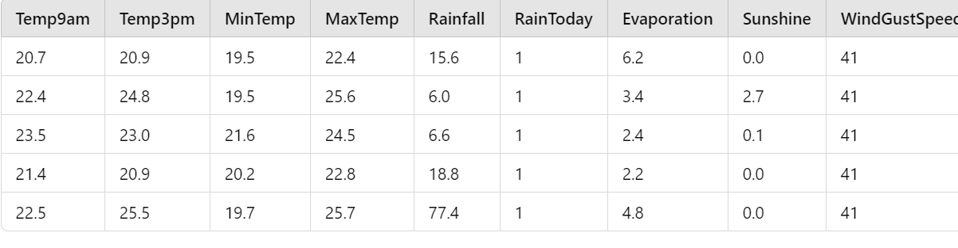

**Data Division**

Data is divided into:

* **Training set**: Used to fit the model and learn the relationship between input features and the target (rainfall).
* **Testing set**: Used to evaluate the model's performance and assess its generalization to unseen data.

The goal of data division is to ensure that the model performs well on real-world data, not just the data it was trained on.

**Logistic Regression:**

A simple and interpretable model that estimates the probability of stroke occurrence based on feature inputs. The logistic regression model was trained to predict stroke probabilities and classify based on a threshold.

**Naive Bayes:**

The Gaussian Naive Bayes model was employed due to its effectiveness with independent features. Each class's probability was calculated, with smoothing applied to prevent issues with zero probability for unseen feature combinations.

**K-Nearest Neighbors (KNN):**

The KNN classifier was trained to predict stroke occurrence based on the proximity of feature values in the training data. This model relies on distance metrics to classify new instances based on their similarity to training examples.

**Support Vector Machine (SVM):**

The linear SVM model was trained to find the optimal hyperplane that separates stroke and non-stroke cases in the feature space. This model is particularly useful for high-dimensional data and works well when the classes are linearly separable.

**Decision Tree:**

A decision tree classifier was built to predict stroke occurrences by recursively partitioning the data based on feature values. This model is interpretable and allows for easy visualization of decision paths.

**Random Forest:**

An ensemble of decision trees was used, where each tree was trained on a random subset of the training data. This model improves predictive accuracy by aggregating the predictions of multiple trees to reduce overfitting.

**XGBoost:**

The XGBoost classifier, known for its performance in structured data, was trained to maximize prediction accuracy by combining weak learners. This gradient boosting model effectively handles various data distributions and missing values.

**Neural Network:**

This model leveraged multiple hidden layers to capture complex patterns in the data.

Forecasting and Assessment

After training, each model was used to predict the occurrence of prediction in the test set. The models’ performances were evaluated based on:

Accuracy: Measures the overall correctness of predictions.

Precision: Indicates the proportion of true positives out of all predicted positives.

Recall: Represents how effectively the model identified all actual positive instances.

F1-Score: Balances precision and recall, especially valuable for datasets with class imbalance.

A confusion matrix was generated for each model to visualize the counts of true positive, true negative, false positive, and false negative predictions. This matrix provides insights into the strengths and weaknesses of each model, highlighting areas for improvement.

The evaluation showed that different models performed variably, with some achieving better accuracy and balance in class predictions than others. The Naive Bayes classifier and Random Forest models produced promising results, while the confusion matrix revealed specific challenges, such as misclassifying stroke occurrence.

#### Methodology of the system

There are several steps involved in the visualisation of data. From the studying of the datasets to plotting it in graphs, each step taken for the visualisation of the data is explained in this section.

Analysing the problem can be done by studying the data sets. By studying the datasets NaN values present in the datasets can be found. In this stage the type of visualisation which can be used for the dataset is selected. Studying the dataset gives a clear view and better understanding of the problem statement.

**Cleaning the Datasets:**

Incorrect data leads to false and inaccurate conclusions. These inconsistencies in the datasets can be due to user error. To correct these inconsistencies data cleaning is used to identify and correcting(or removing) all the inaccurate records present in the dataset. Data cleaning can find out the inaccurate, incomplete, irrelevant and incorrect parts of the data and remove or replace them with median values. There are many tools available for data cleaning, in this paper pandas library is used for the cleaning of data.

**Data Preprocessing:**

Good quality of data needs to be accurate, precise, consistent and uniform. Data Processing is used to achieve the quality standards of a dataset. Data Preprocessing is used to convert the raw data into a more refined and useful one. Data preprocessing is very important as it improves the quality of the raw data and helps in achieving better results.

**Algorithm and Methods:**

The data present in the datasets is visualised in this stage. In this paper, bar graph is used to visualise the highs and lows of rainfall in each state and maximum and minimum rainfall of all the states is compared. Line graph is used for visualising the annual rainfall of each state from 1901-2015. Both bar and line graph, been very simple and familiar, is best suited for the dataset used.

Line graph are plotted using matplotlib.pyplot library and bar graphs are plotted using the seaborn library.

**Classifier Layer:**

To build a **classifier model** for the dataset, the target variable must be categorical. Since you are looking for a **classifier layer**, I assume we are working on predicting whether it **rains today** (yes/no) or another binary/multiclass classification task.

Given that the **RainToday** column is a binary variable (1 for Yes, 0 for No), we can treat it as the target variable for classification.

**Key Steps for the Classifier Model:**

1. **Input Data**: The features of the dataset (excluding the target variable RainToday).
2. **Target Variable**: The binary target column, RainToday.
3. **Classifier Model**: We will create a classification layer using models like Logistic Regression, Random Forest, or Neural Networks.

**Output Layer:**

The system presents the classification outcome, indicating the rainfall (1 = yes, 0 = No ) based on the input data and model predictions.

1. **Model Training**

Various models were implemented to tackle the stroke prediction problem, including:

**Logistic Regression:**

Chosen for its interpretability, this model estimates the probability of stroke occurrence based on input features.

**Naive Bayes:**

The Gaussian Naive Bayes classifier was utilized due to its efficiency with categorical and continuous data. This model computes probabilities for each class based on the assumption that features are conditionally independent.

**K-Nearest Neighbors (KNN):**

KNN was employed to classify stroke cases based on the distance of feature values to the nearest training samples.

**Support Vector Machine (SVM):**

A linear SVM model was trained to identify the optimal hyperplane for separating stroke and non-stroke instances.

**Decision Trees and Random Forests:**

Decision Trees were used for their interpretability, while Random Forests enhanced prediction accuracy by aggregating results from multiple trees.

**XGBoost:**

The XGBoost model leveraged gradient boosting to maximize prediction accuracy, effectively handling complex relationships in the data.

**Neural Network:**

A simple feedforward neural network was implemented to capture non-linear relationships in the data.

1. **Classification**

The classification task involved predicting the occurrence of stroke using the trained models. Each model was evaluated based on accuracy, precision, recall, and F1-score to assess performance. The confusion matrix provided a detailed overview of model predictions, allowing for insights into the classification of stroke instances.

1. **Results**

The output of the system is a status of rainfall prediction within the dataset. After training, the system accurately estimates rainfall (1 = Yes, 0 = No ) based on new data.

The system's performance was measured using various metrics, demonstrating its potential utility in clinical settings for stroke prediction. Overall, the hybrid approach, utilizing multiple models, contributed to improved accuracy and reliability in classifying stroke severity.

**Methodology:**

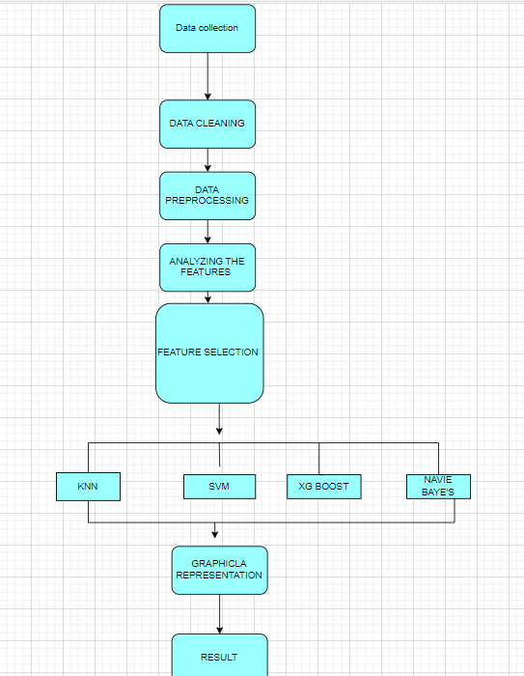

#### Model Evaluation

**A. Confusion Matrix**

The classification performance of each model was assessed using confusion matrices, which provide a detailed analysis of true positives, false positives, true negatives, and false negatives for the binary classification .The matrices helped identify:

How often each model successfully classified stroke occurrences. Areas where the models struggled, such as distinguishing between the two classes in an imbalanced dataset.

**B. Accuracy**

Accuracy is defined as the proportion of accurately predicted instances (true positives and true negatives) to the total instances. Although it serves as a general indicator of model performance, it may be misleading in the context of an imbalanced dataset. Here, accuracy was considered as a foundational metric.

**C. Precision**

Precision quantifies the percentage of accurate positive predictions. In this study, it reflects the proportion of instances that were correctly identified as stroke cases out of all predicted stroke cases. Precision is crucial when the cost of false positives is high, as it minimizes incorrect classifications into the positive class.

**D. Recall**

Recall, also known as sensitivity, measures the proportion of actual positive instances that were correctly detected. It illustrates how effectively the model identifies stroke cases, aiming to reduce the number of missed cases (false negatives) and ensure that most true positives are captured.

**E. F1-Score**

The F1-score is the harmonic mean of precision and recall, providing a single metric that balances both. It is particularly useful in scenarios where there is an imbalance in class distributions or when both precision and recall are equally important. A high F1-score indicates good model performance in classification.

**F. Performance Outcomes**

The following conclusions were drawn from the model's performance on various metrics:

Training Accuracy: Indicates how well the model learned patterns from the training data.

Testing Accuracy: Reflects how effectively the model performs on unseen data.

Precision and Recall: Aided in assessing the model's ability to correctly classify stroke instances and avoid false classifications.

F1-Score: Provided a comprehensive measure of the model’s performance, showcasing the balance between precision and recall.

Based on evaluation results, the models showed varying degrees of success in predicting strokes. The hybrid approach, employing multiple algorithms, allowed for improved accuracy and reliability in predictions.

**G. Individual Model Performance**

**Logistic Regression:**

The Logistic Regression Classifier achieved a cross-validation accuracy of 78% and a test accuracy of 78%. Precision, recall, and F1-score were reported for both negative (class 0) and positive (class 1) instances. The overall accuracy of the classifier was 78%. The macro average for precision, recall, and F1-score across both classes was 73%, 76%, and 74%, respectively. The weighted average, considering class imbalance, reported 88% precision, 80% recall, and a 84% F1-score.

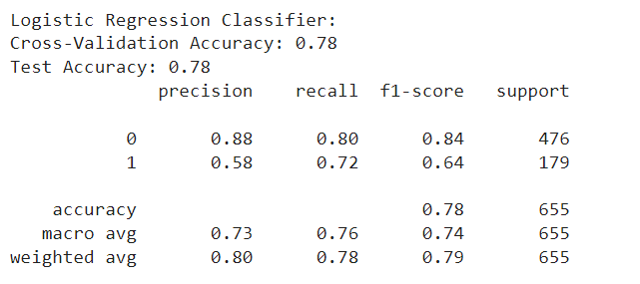

Figure 2. Logistic Regression

**Support Vector Machine (SVM):**

The SVM Classifier achieved a cross-validation accuracy of 93% and a test accuracy of 74%. For class 0, the precision was 75%, recall was 96%, and the F1-score was 84%, while class 1 had a precision of 59%, recall of 16%, and an F1-score of 25%. The model performs well in identifying negative instances (class 0) but struggles with positive instances (class 1). Despite the imbalance, the overall weighted averages for precision, recall, and F1-score were 71%, 74%, and 68%, respectively.

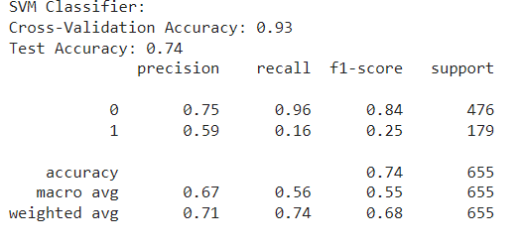

**Random Forest:**

Trained with 100 trees, the Random Forest model exhibited robust performance and resilience to overfitting, resulting in good accuracy and stability. The Random Forest Classifier achieved a cross-validation accuracy of 89% and a test accuracy of 80%. Precision, recall, and F1-score were reported for both negative (class 0) and positive (class1) instances.

The overall accuracy of the model was 80%, with a macro average of 74% for precision, recall, and F1-score across both classes. The weighted average, which accounts for class imbalance, reported 79% precision, 80% recall, and a 79% F1-score.

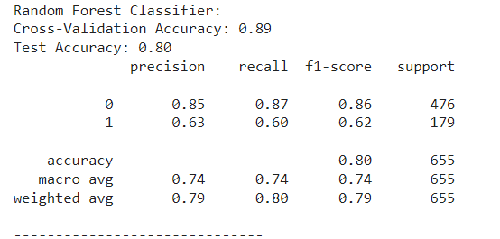

**XGBoost:**

Using an XGBoost classifier, the model achieved a cross-validation accuracy of 0.89 and a test accuracy of 0.80. Class 0 has higher precision (0.84) and recall (0.88) compared to Class 1, which has lower precision (0.64) and recall (0.56). The macro average F1 score is 0.73, indicating moderate performance across both classes. Overall, the model performs well for Class 0, but Class 1's performance is relatively weaker.

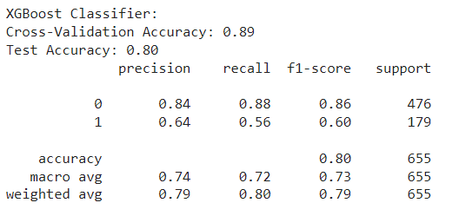

**K-Nearest Neighbors (KNN):**

The K-Nearest Neighbors (KNN) classifier achieved a cross-validation accuracy of 88% and a test accuracy of 75%. The performance was evaluated using precision, recall, and F1-score for both negative (class 0) and positive (class 1) instances. For class 0, the precision was 86%, recall was 78%, and the F1-score was 82%, indicating strong identification of negative instances. For class 1, precision was 53%, recall was 65%, and the F1-score was 59%, showing that the classifier was less effective at identifying positive instances. The overall accuracy of the model was 75%, with a macro average F1-score of 70% and a weighted average F1-score of 76%, reflecting the classifier's moderate performance across both classes.

The Random Forest Classifier achieved a cross-validation accuracy of 89% and a test accuracy of 80%. Precision, recall, and F1-score were reported for both negative (class 0) and positive (class1) instances.

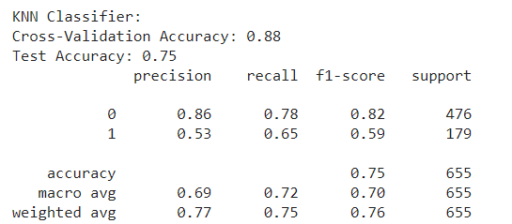

**Artificial Neural Network (ANN) :**

Using an Artificial Neural Network (ANN) classifier, the model achieved a cross-validation accuracy of 0.89 and a test accuracy of 0.76. Class 0 has a higher precision (0.83) and recall (0.84) compared to Class 1, which has lower precision (0.56) and recall (0.53). The macro average F1 score is 0.69, showing moderate performance overall. Class 1's performance is significantly weaker than Class 0's.

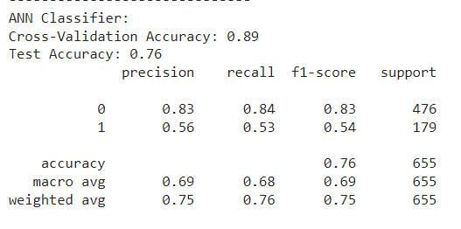

|  |  |  |  |  |
| --- | --- | --- | --- | --- |
| **Model** | **Accuracy** | **Precision** | **Recall** | **F1 Score** |
| Logistic Regression | 0.78 | 0.73 | 0.76 | 0.72 |
| ANN | 0.89 | 0.83 | 0.84 | 0.83 |
| Support Vector Machine | 0. 93 | 0.75 | 0.96 | 0.84 |
| Random Forest | 0.89 | 0.85 | 0.87 | 0.86 |
| XGBoost | 0. .89 | 0.84 | 0.88 | 0.86 |
| KNN | 0.88 | 86 | 78 | 82 |

Table 1. Recorded Results for each Classifier

**Graphical representation:**

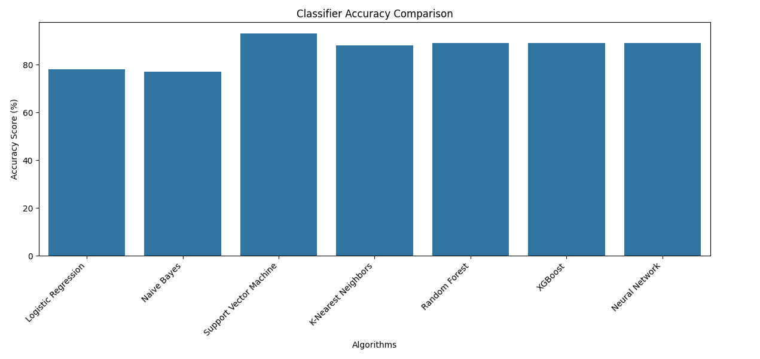

# CHAPTER - 6

**CONCLUSION**

In conclusion, this experiment underscores the potential of machine learning approaches in enhancing rainfall prediction. Through the systematic implementation and evaluation of various machine learning models, including Logistic Regression, Naive Bayes, Support Vector Machine (SVM), Random Forest, K-Nearest Neighbors (KNN), and XGBoost.The weather dataset provides detailed information about daily weather conditions, including temperature, rainfall, wind, and other atmospheric factors. Temperature readings at 9 AM and 3 PM, along with minimum and maximum values, show daily variations and give insight into the fluctuations throughout the day. Rainfall data, combined with the "RainToday" indicator, highlights the frequency of rainy days, while evaporation measurements suggest the amount of water loss on different days. Wind data, including direction and speed, reveals the dynamic nature of wind patterns, contributing to changes in weather. Humidity levels at both 9 AM and 3 PM provide an understanding of moisture levels throughout the day, which are essential in assessing comfort and potential weather changes. Atmospheric pressure readings, along with cloud cover measurements at two different times of the day, offer a clear picture of the conditions that may lead to changes in weather. Overall, the dataset provides a comprehensive view of weather patterns, enabling further analysis for forecasting or studying environmental conditions.

**REFERENCES:**

1.M. Mohammed, R. Kolapalli, N. Golla, SS. Maturi, Int J Sci Technol Res. 9(1), 3236–40 (2020).

2.N. Oswal, arXiv preprint arXiv, 1910, 13827 ((2019).

3.G. Rudrappa, Rev Gestão Inovação e Tecnol. 11(3), 179–87 (2021).

Google ScholarCrossref .

4.F. Yulianto, WF. Mahmudy, AA. Soebroto, J Inf Technol Comput Sci. 5(3), 235–47 (2020).

Google Scholar.

5.M.T. Anwar, W. Hadikurniawati, E. Winarno, W. Widiyatmoko, “Performance Comparison of Data Mining Techniques for Rain Prediction Models in Indonesia,” 2020 3rd Int Semin Res Inf Technol Intell Syst ISRITI 2020. (2020, December), pp. 83–88.Google ScholarCrossref .

6.NB. Dudde, SS. Apte, Int J Sci Res. 5(3), 87–9 (2016).Google Scholar .

7.N.W. Zamani, S.S.M. Khairi, “A comparative study on data mining techniques for rainfall prediction in Subang,” (AIP Conf Proc., 2018).Google Scholar.

8.S. Goyal, N. Mittal, and A. Rana, “Analyzing Trend Probability and Risk Estimation of Rainfall Pattern over Maharashtra,” In 2021 9th International Conference on Reliability, Infocom Technologies and Optimization (Trends and Future Directions) (ICRITO) (IEEE., 2021, September) pp. 1–5.Google ScholarCrossref .

9.J. Diez-Sierra, M. del Jesus, J. Hydrol. 586, 124789 (2020).https://doi.org/10.1016/j.jhydrol.2020.124789Google ScholarCrossref .

10.G.B. Sai Tarun, J.V. Sriram, K. Sairam, K.T. Sreenivas, M.V.B.T. Santhi, Int J Innovative Technol Exploring Eng, 8 (7), 957–63 (2019)Google Scholar .

11.S. Kulkarni, M. Mushrif, “Comparative study among different neural net learning algorithms applied to rainfall predication,” Proc - Int Conf Electron Syst Signal Process Comput Technol ICESC 2014. (2014), pp. 209–16.Google Scholar .

12.S. Aftab, M. Ahmad, N. Hameed, M.S. Bashir, I. Ali, Z. Nawaz, Int J Adv Comput Sci Appl. 9(4), pp. 254–60 (2018).Google Scholar

13.E. Share, M. Therapy, T. American, H. Dictionary, E. Language, C. Cong-fou, et al, Disclaimer, 1–6 (2021).Google Scholar .

14.N.K.A. Appiah-Badu, Y.M. Missah, L.K. Amekudzi, N. Ussiph, T. Frimpong, E. Ahene, “Rainfall Prediction Using Machine Learning Algorithms for the Various Ecological Zones of Ghana,” (IEEE Access. 2021), PP: 1–1.Google Scholar .

15.S. Zainudin, D.S. Jasim, A.A. Bakar, Int J Adv Sci Eng Inf Technol. 6(6), 1148–53(2016).https://doi.org/10.18517/ijaseit.6.6.1487Google ScholarCrossref /

16.F.Q. Kareem, A.M. Abdulazeez, D.A. Hasan, Asian J. Res. Comput. Sci. AJRCOS, 9(3), 13–24 (2021).Google Scholar .

17.W.M. Ridwan, M. Sapitang, A. Aziz, K.F. Kushiar, A.N. Ahmed, A. El-Shafie, Malaysia. Ain Shams Eng J. 12(2), 1651–1663 (2021).https://doi.org/10.1016/j.asej.2020.09.011Google ScholarCrossref .

18.J.J. Berman, Chapter 4, Berman JJBT-DS, editor. (Boston: Morgan Kaufmann, 2016), p. 135–87.Google Scholar .

19.M. Korkmaz, S. Güney, Ş. Yiğîter, J Fac Agric Harran Univ. 16(2), 25–36 (2012).Google Scholar .

20.R.D. Raizada, Y.S. Lee, PLoS One. 8(7), e69566 (2013).https://doi.org/10.1371/journal.pone.0069566.Google ScholarCrossref PubMed .

21.N.E. Helwig, Permutation Tests Copyright c 2017 (by Nathaniel E. Helwig. 2017).

22.B. Akkaya, N. Çolakoğlu, “Comparison of Multi-class Classification Algorithms on Early Diagnosis of Heart Diseases,” (2019).Google Scholar .

23.L. Liu, J. Lin, P. Wang, L. Liu, R. Zhou, Discrete Dyn. Nat. Soc.(2020).Google Scho